Using the Error Propagation Code in a Jupyter Notebook

Part 1: If you have installed Jupyter Notebook/Python on your laptop

- Download the ErrorPropagationCode2022.ipynb from the TL2 OnQ page and save it into your APSC102 folder.
- From your Start menu – click on Anaconda Navigator
- Click Launch under the JupyterLab Icon
If the button says Install, click it and wait until it changes to Launch

- Jupyter Lab will open in a new window. Down the left side you will see a series of folders and files. Look in the “Documents” folder for the ErrorPropagationCode2022.
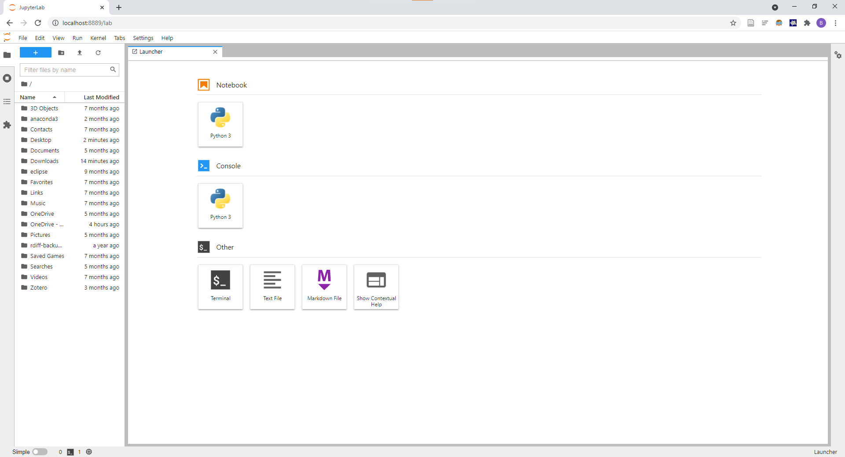

- Once you have opened the code, run all cells by going Run -> Run All Cells. Or click on Cells > Run All
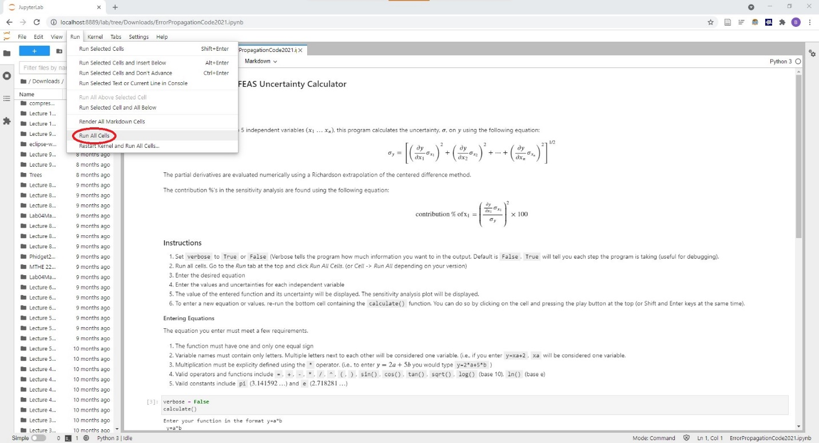
- Enter your equation and variable values and associated uncertainties when prompted. Review the embedded Instructions and Entering Equations section in the notebook for more information on entering the equations properly.
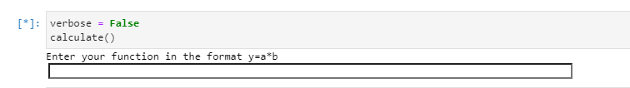
- After entering the function and values, the result of the calculation and its associated uncertainty will be displayed, along with the Sensitivity Analysis plot. If the Sensitivity Analysis plot doesn’t appear, it is probably minimised. Look along your bottom taskbar to find it.
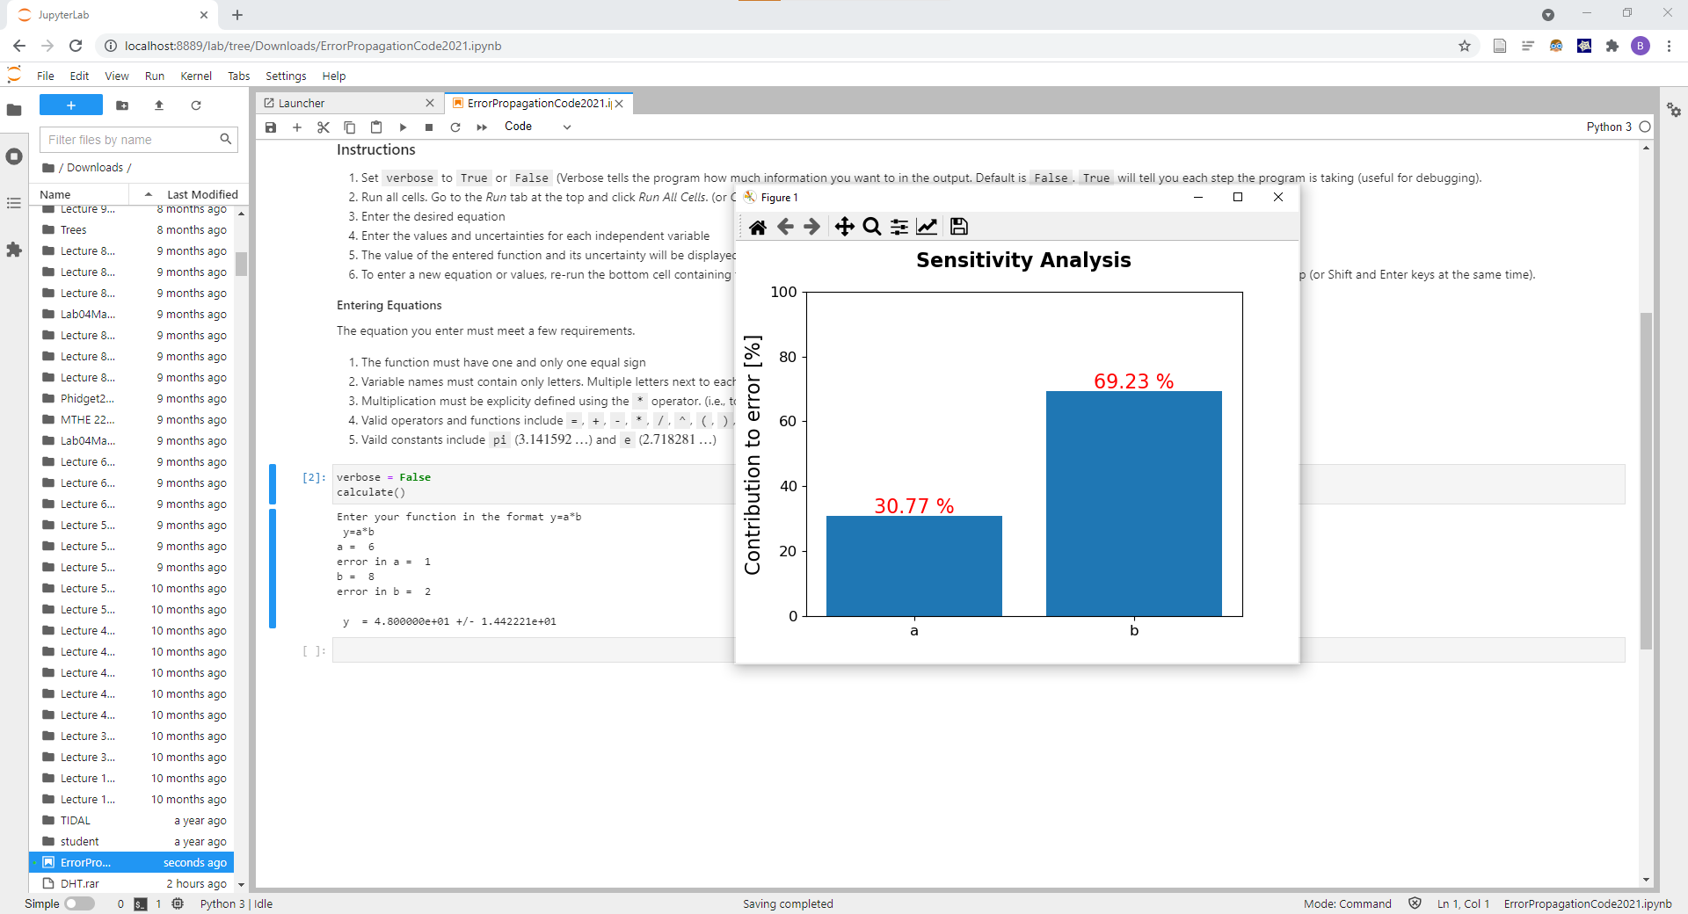

- To start a new calculation, ensure the cell with the calculate() line is highlighted (blue line next to it, as seen in the picture directly above) and click at the top of the page, or press Shift and Return simultaneously to run the cell.
Before trying to run the cell again, ensure it is not actively running as indicated by an asterisk next to the cell. (Ex. or 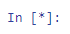) If it is running, make sure the cell is highlighted and then press the stop button at the top of the page ().

Part 2: If you are using the Online Sysygy version of Jupyter/Python
- Download the ErrorPropagationCode2022.ipynb from the TL2 OnQ page and save it into your APSC102 folder.
- Go to https://queensu.syzygy.ca/ and sign in using your Queen’s NetID and password.
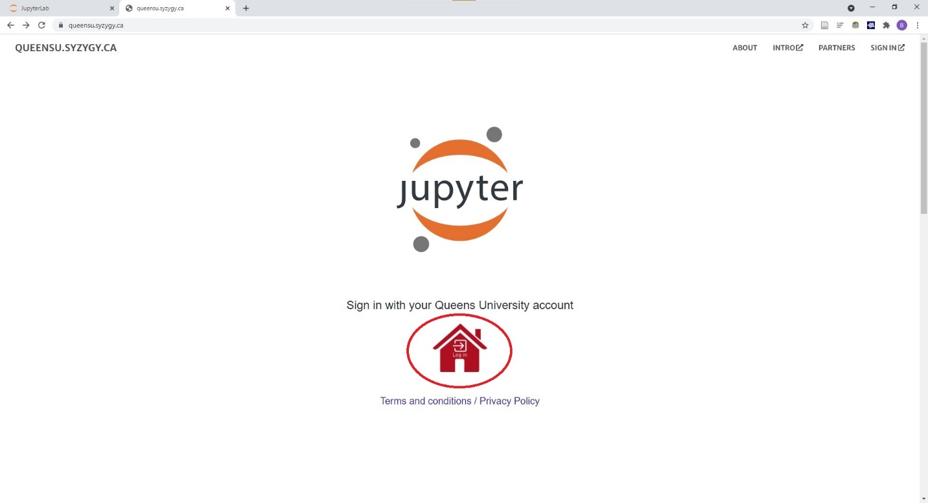
- Upload the code you downloaded from OnQ by clicking upload and then navigating to the file.
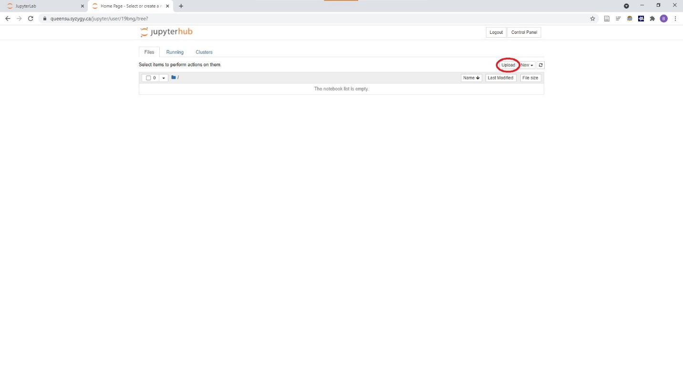
- Click upload once again to complete the process
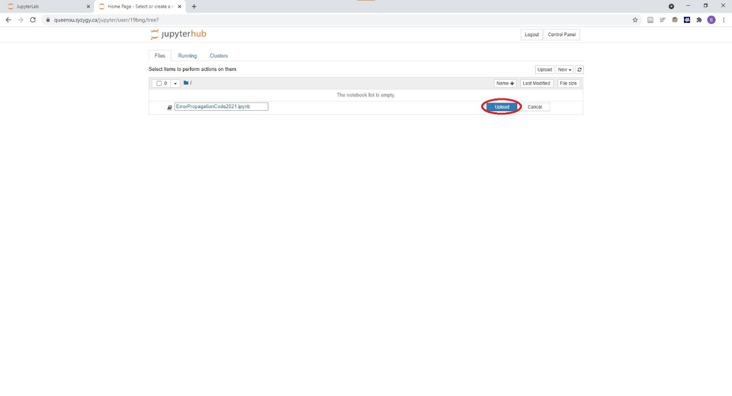
- Click on the name of the code to launch the notebook view
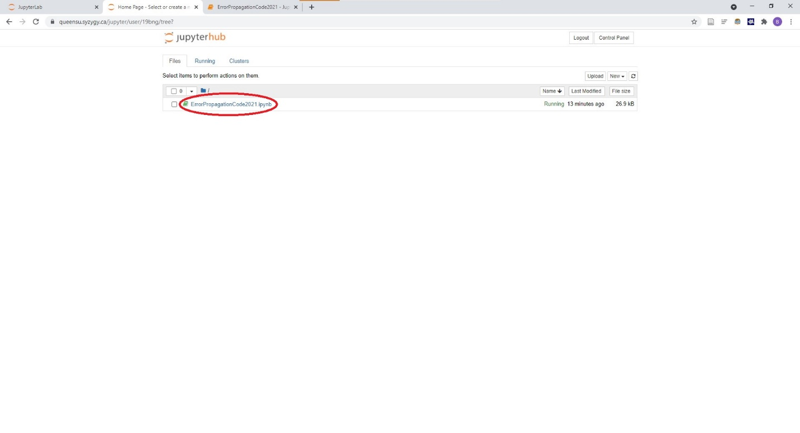
- Run all cells by going Cell -> Run All
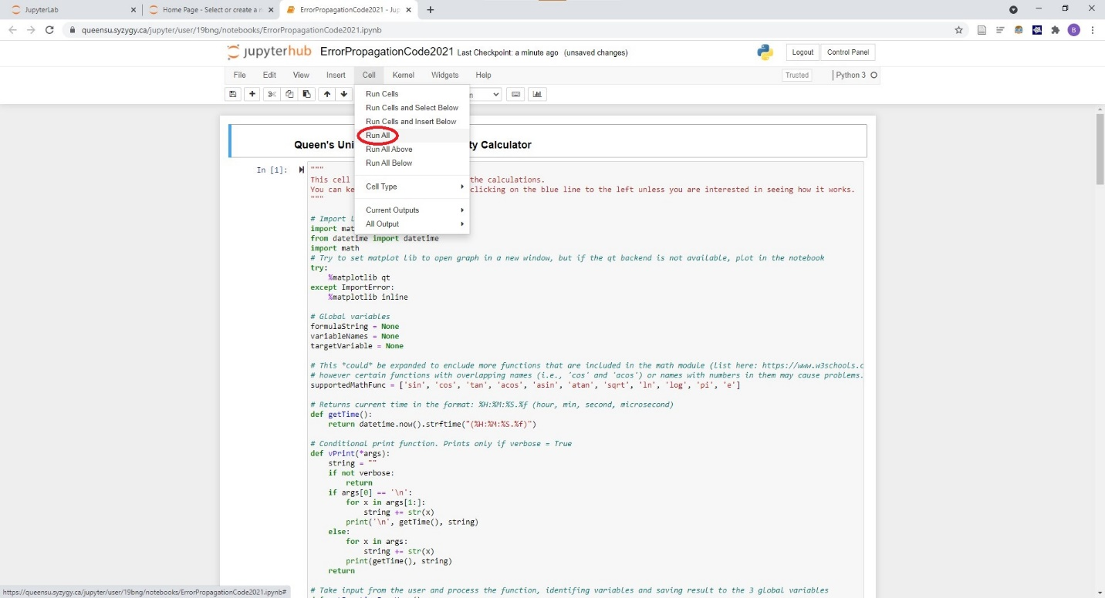
- Enter your function and variable values and associated uncertainties when prompted. Review the embedded Instructions and Entering Equations section in the notebook for more information on entering the equations properly.
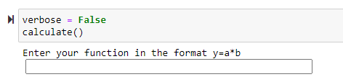
- After entering the function and values, the result of the calculation and its associated uncertainty will be displayed, along with the Sensitivity Analysis plot.
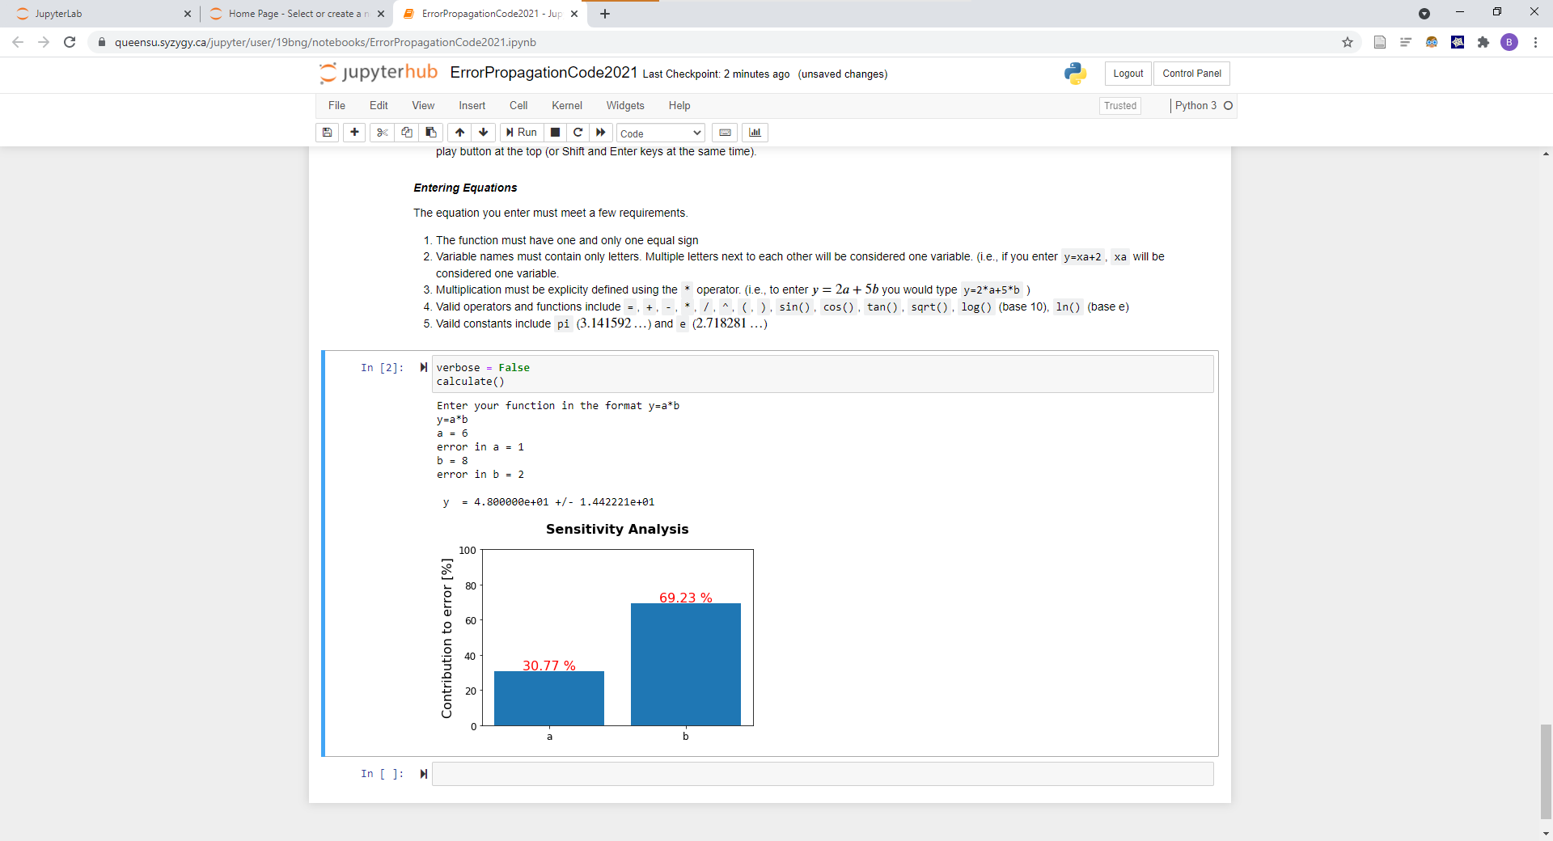
- To start a new calculation, ensure the cell with the calculate() line is highlighted (blue line next to it, as seen in the picture directly above) and click at the top of the page, or press Shift and Return simultaneously to run the cell.
Before trying to run the cell again, ensure it is not actively running as indicated by an asterisk next to the cell (Ex. or ). If it is running, make sure the cell is highlighted and then press the stop button at the top of the page ().

